Patuxent High School Bands
Percussion Ensemble Syllabus

Mr. Stephen Lane, Director
lanes@calvertnet.k12.md.us
443-550-8840 ext. 5

Course Description: The Patuxent High School Percussion Ensemble is open to any student in grades 9-12 with any level of experience and ability playing percussion. Rehearsals occur every day during the school year. The ensemble performs two concerts annually with possible additional performances for special events and community involvement. Students will gain an understanding of percussion techniques as well as building individual and ensemble skills. The repertoire performed will expose students to a wide variety of musical types, styles and examples of quality ensemble music. All pieces will have goals aimed at teaching/learning core objectives and entertaining. Students will be given the opportunity to perform in both large and small ensemble settings.

Mission Statement: To provide each student with a commitment to musical excellence through opportunities and experiences that cultivate servant leadership, self-improvement and personal development.

Website/Calendar: www.patuxentband.com
Please check the Patuxent High School Band website regularly for a full calendar of events and updates on every performing ensemble we have to offer.

Important Dates
Attendance at the events below is MANDATORY! Please make sure you have cleared these dates in your calendar! You are expected to schedule your events around these dates.
- All-County Band/Jazz Audition Recordings Completed: Monday, October 21st (Optional)
- All-County Band Concert: Thursday, November 14th, 7pm @ CHS (Optional)
- Winter Concert Dress Rehearsal: Thursday, December 5th, 2:30pm-6pm
- Winter Concert: Thursday, December 12th, Report 6pm (Concert 7pm)
- District Solo & Ensemble Application Due: Wednesday, January 15th
- District Solo & Ensemble Festival: Saturday, February 15th @ Calvert MS (Optional)
- District Festival Dress Rehearsal: Thursday, February 20th, 2:30 – 6pm
- District XII Festival: Wednesday, February 26th @ CHS, Time TBA
- Mulch Sale: Saturday, April 4th 7:30am-1:00pm
- Spring Concert Dress Rehearsal: Tuesday, April 21st, 2:30pm – 6pm
- Spring Concert: Thursday, April 23rd, Report 6pm (Concert 7pm)
- State Solo & Ensemble Festival: Saturday, May 16th @ Towson University (Optional)
- Graduation: Wednesday, June 3rd
Performance Attire:
Required dress for all Wind Ensemble Performances is listed below:
- Men:
- Students will be required to obtain black dress pants, black dress shoes and black dress socks.
  - Sneakers are not permitted to wear for performances.
- Students will need to return the attached uniform information sheet with $30 for their black dress shirt and matching tie to be ordered by the Band Department.
- If you have any issues obtaining any of the required items, please let Mr. Lane know immediately so arrangements can be made.

- Women: Concert Dress (Provided by PHS)
  - Dress will be kept at school and returned to the uniform room after each performance.
  - Black Dress Shoes (Student provides – sneakers are not permitted)
  - If preferred, you may purchase the black dress shirt and tie for $30 using the form attached.
    - You would still need to provide your own black dress pants, black socks and black dress shoes.

Expectations:
- All Calvert County and Patuxent High School policies apply in this class.
- Phones, iPods, tablets, headphones, etc. should not be visible during class. Students will be issued one warning, and if the problem persists, the items will be confiscated or turned into an administrator. Phones may be used at times for tuning apps and other uses in the classroom but should be used for this purpose only.
- It is your responsibility to be in class on time, be prepared, and be ready to learn.
- There should never be food or drinks in the band room at any time (with the exception of water).
- Gum is not permitted in class.
- You are expected to treat your instrument and the school instruments with care and respect. Please respect other students’ instruments and do not play them without permission.

Required Materials:
Students should have the materials below with them in class every day.
- Pencils are required EVERY DAY for class.
The following items can be obtained from a local music store OR www.steveweissmusic.com
- Practice Pad (Vic Firth Pad12 Single Sided Practice Pad Recommended)
- Drum Sticks (Innovative IP 1 General Hickory, or Vic Firth SD1-General Recommended)
If you have any issues providing the required materials, please contact Mr. Lane

Grading Policy: Band classes at PHS are different than a typical class. Because of the performance nature, students are required to attend certain events outside of the school day. This is necessary to teach students how to perform in front of an audience and demonstrate their skills. As such, it is impossible to replicate this experience during our class time. Therefore, it is crucial that they attend each performance for the dates listed above. The process for making up a missed performance is listed below in the “Make-Up Work” section. Please refer to the below policy of how students will be assessed each marking period.

Concert Attendance and Performance: - 45%
Students are given the opportunity to earn 45% of their grade through dress rehearsal and concert performance. Students will receive full credit by attending the dress rehearsal prepared and reporting to the concert on time, in their uniform, with all the equipment they need to perform. Appropriate behavior and performance are also included in this grade. The post-concert assessment completed by each student is a separate grade but part of the 45% portion.

Playing Tests/Written Assignments: - 25%
Throughout each marking period, students will be assigned a variety of tasks. Student assessment will be recorded through individual playing for the director on his/her instrument. Students will also be required to complete written assignments on occasion.

Daily Achievement of Curriculum Standards: - 30%
Twenty percent of the student’s grade will be determined through their daily achievement. This includes but is not limited to: reporting to class on time, controlling him/her self in an appropriate manner to ensure the best learning environment is maintained for all learners, being prepared with all materials, showing adequate progress through means of individual practice outside of class.

Scale/Rudiment Studies: In addition to the playing tests as outlined above, students will be expected to play from the 40 essential rudiments and major/minor scales. Students will be made aware when each scale and rudiment is due.
- Students can find additional help with rudiments at the following web address: http://www.vicfirth.com/education/rudiments.php

Percussion Section: It is the responsibility of the percussion section to maintain a clean and orderly section. Each instrument has its own labeled spot. It is expected that the percussion ensemble will return the instruments and accessories to their appropriate place upon the completion of each rehearsal.

Late Work: Each assignment is due on its due date in class. Assignments that are not turned in on time will not be given full credit and will be graded at the director’s discretion.

Make-Up Work: If students must miss class or a performance due to illness or other unavoidable circumstances, it is the responsibility of the student to retrieve and make up assignments that were missed. If a student is absent on the day an assignment is due, they must arrange a time to make up the assessment with Mr. Lane either during lunch or before/after school.

*Make up opportunities will be provided for missed performances but will still have a performance component. Students will have to prepare a solo etude chosen by Mr. Lane to perform for the ensemble by the end of the grading period. It will be their responsibility to prepare this piece and perform it at an acceptable level.

Practice: The pace and rigor of this course are designed with the assumption that students will practice outside of the school day. It is impossible for Mr. Lane to break down every measure of every part in each rehearsal. If students are having trouble with a specific piece, they are expected to take it upon themselves to practice or ask Mr. Lane for assistance.

Fundraising: The equipment that is used by the PHS Band program is expensive to purchase, repair, and maintain. Because of this cost, there will be many fundraisers throughout the year that we need each student’s help in achieving. Without these fundraisers, we would not have the equipment we need. Fundraising is also used to provide students with guest clinicians and other experiences that elevate their learning experience.
- PHS Band students are expected to participate in all fundraisers!
- *All students are required to participate in the spring mulch sale! More information about this event will become available as known. This is our biggest fundraiser of the year!

Resources:
Band Website: http://patuxentband.com
Metronome Online: http://metronomeonline.com - Use a metronome every time you practice!
Steve Weiss: http://www.steveweissmusic.com - Percussion accessories and equipment.

Additional Performance Opportunities:
There are multiple opportunities for band students to play in ensembles at the County, Tri-County and All-State levels, as well as competing in Solo and Ensemble. Additional opportunities are available for High School Honor Bands at various Colleges and Universities throughout the year. These opportunities are available to students if they are willing to put in the extra work to prepare for them. Details for these events will be handed out in class as the dates approach. These are not required events, but students are encouraged to explore these opportunities!

*Mr. Lane reserves the right to change this syllabus as it becomes necessary. Should this happen, students will be made aware of the changes and be given a new copy of the syllabus. *

--------------------Detach and return by Friday, September 13th------------------

Signature of Acknowledgement
By signing below, you and your guardian acknowledge that you have read the syllabus for this class and agree to the policies and statements included. You also agree that any concert/dress rehearsal conflicts are noted below, and absence from any of the “Important Events” will result in the lowering of the class grade if make up tasks are not complete. I further understand that I will be held financially responsible for all uniforms and instruments lent to me. If they are not returned in satisfactory condition (beyond normal wear from use), I agree to reimburse PHS the amount necessary to return them to a satisfactory condition or replace them.

Student Name (Printed) _________________________________________________________________

Grade _______

Guardian Mailing Address_______________________________________________________________

Guardian Cell Phone ___________________________________________________________________

Guardian Work Phone __________________________________________________________________

Guardian Email Address ________________________________________________________________

Student Signature _________________________________ Date ______________________________

Guardian Signature ________________________________ Date ______________________________

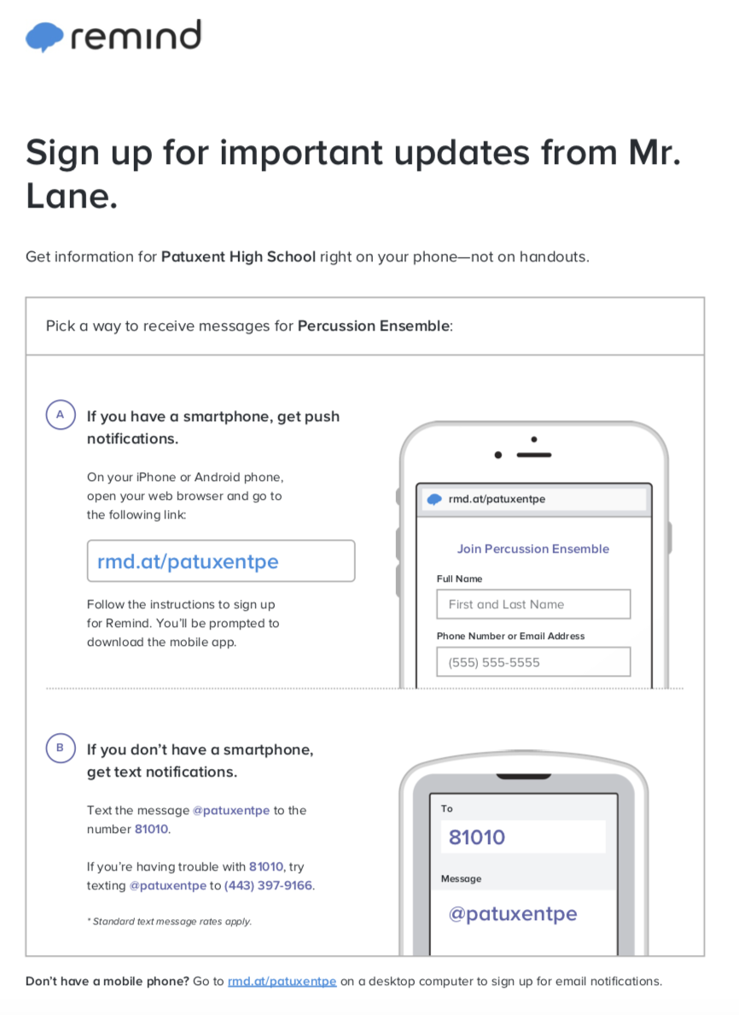

PHS Band Department Uniforms

The band department will be switching over to a new affordable uniform for our concert/performance attire. Students will provide and wear black dress shoes, black socks, and black pants. Each student will have a one time fee of $30 for their black dress shirt and green tie which will be purchased by the band department. Students will be able to reuse their own uniform and keep both the tie and shirt after graduation. If you have any questions please email Mr. Lane at lanes@calvertnet.k12.md.us.
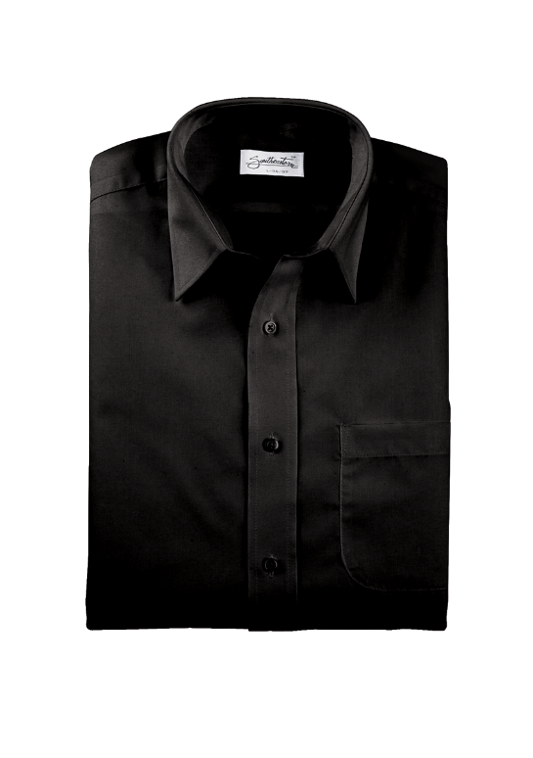
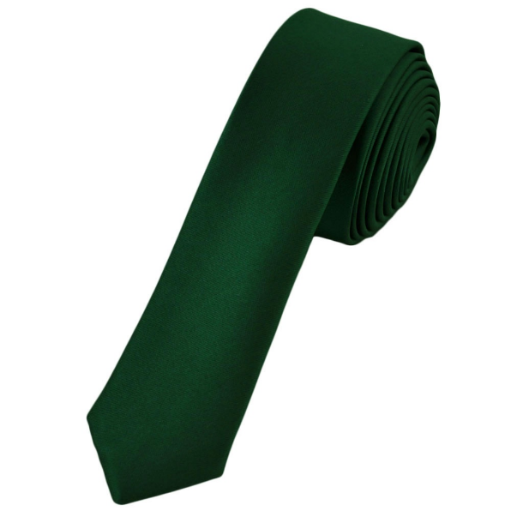

Southeastern Performance Apparel
A size chart is provided on the back for your convenience. If you are not sure of what size to get, our uniform chair will take measurements for you!

Please fill out the form on the back of this paper and either attach cash or check in the amount of $30. Checks may be made out to Patuxent High School.

Uniform Order Form

Student Name:
Ensemble:
Neck Size: Sleeve Size: Needs Measurements:
Please check one of the following:
_____ Check made out to Patuxent High School for $30 attached
_____ Cash in an envelope labeled with student name attached

